**Task 1:**

#include <stdio.h>

int main() {

    int num1, num2;

    int *ptr1, *ptr2, sum;

    printf("Enter the first number: ");

    scanf("%d", &num1);

    printf("Enter the second number: ");

    scanf("%d", &num2);

    ptr1 = &num1;

    ptr2 = &num2;

    sum = *ptr1 + *ptr2;

    printf("Sum of the two numbers is: %d\n", sum);

    return 0;

}

**Output:**

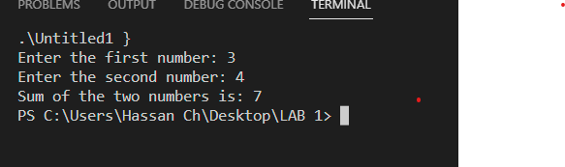

**Task 2:**

#include <stdio.h>

void generateFibonacci(int n) {

    if (n <= 0) {

        return;

    }

    int first = 0, second = 1, next;

    int *ptrFirst = &first, *ptrSecond = &second;

    printf("Fibonacci Series up to %d terms:\n", n);

    for (int i = 1; i <= n; ++i) {

        printf("%d, ", *ptrFirst);

        next = *ptrFirst + *ptrSecond;

        *ptrFirst = *ptrSecond;

        *ptrSecond = next;

    }

    printf("\n");

}

int main() {

    int terms;

    printf("Enter the number of terms in the Fibonacci series: ");

    scanf("%d", &terms);

    generateFibonacci(terms);

    return 0;

}

**Output:**

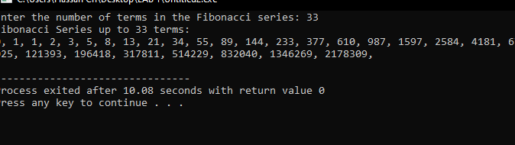

**Task 3:**

#include <stdio.h>

int findGCD(int a, int b) {

    int *ptrA = &a, *ptrB = &b;

    while (*ptrA != *ptrB) {

        if (*ptrA > *ptrB) {

            *ptrA = *ptrA - *ptrB;

        } else {

            *ptrB = *ptrB - *ptrA;

        }

    }

    return *ptrA;

}

int main() {

    int num1, num2;

    printf("Enter the first number: ");

    scanf("%d", &num1);

    printf("Enter the second number: ");

    scanf("%d", &num2);

    int gcd = findGCD(num1, num2);

    printf("GCD of %d and %d is: %d\n", num1, num2, gcd);

    return 0;

}

**Output:**

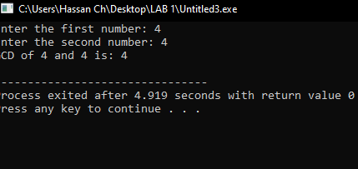

**Task 4:**

#include <stdio.h>

int reverseNumber(int number) {

    int reversed = 0;

    int *ptrReversed = &reversed;

    while (number != 0) {

        int digit = number % 10;

        *ptrReversed = (*ptrReversed) * 10 + digit;

        number /= 10;

    }

    return *ptrReversed;

}

int main() {

    int num;

    printf("Enter a number: ");

    scanf("%d", &num);

    int reversed = reverseNumber(num);

    printf("Reversed number: %d\n", reversed);

    return 0;

}

**Output:**

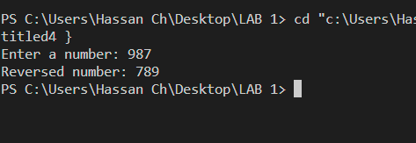

**Task 5:**

#include <stdio.h>

#include <stdbool.h>

bool isPrime(int *num) {

    if (*num <= 1) {

        return false;

    }

    for (int i = 2; i * i <= *num; ++i) {

        if (*num % i == 0) {

            return false;

        }

    }

    return true;

}

int main() {

    int num;

    printf("Enter a number: ");

    scanf("%d", &num);

    if (isPrime(&num)) {

        printf("%d is a prime number.\n", num);

    } else {

        printf("%d is not a prime number.\n", num);

    }

    return 0;

}

**Output:**

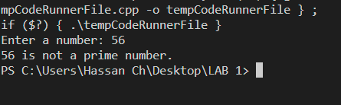

**Task 6:**

#include <stdio.h>

int isPalindrome(int *num) {

    int original = *num;

    int reversed = 0;

    int remainder;

    while (*num > 0) {

        remainder = *num % 10;

        reversed = reversed * 10 + remainder;

        *num /= 10;

    }

    return (original == reversed);

}

int main() {

    int num;

    printf("Enter a number: ");

    scanf("%d", &num);

    if (isPalindrome(&num)) {

        printf("%d is a palindrome.\n", num);

    } else {

        printf("%d is not a palindrome.\n", num);

    }

    return 0;

}

**OUTPUT:**

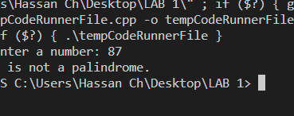

**Task 7:**

#include <stdio.h>

int sumOfDigits(int *num) {

    int original = *num;

    int sum ;

    while (*num > 0) {

        sum += *num % 10;

        *num /= 10;

    }

    return sum;

}

int main() {

    int num;

    printf("Enter a number: ");

    scanf("%d", &num);

    int sum = sumofDigits(&num);

    printf("Sum of the digits of %d is: %d\n", num, sum);

    return 0;

}

**Output:**

:

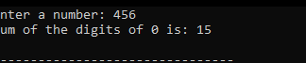

**Task 8:**

#include <stdio.h>

int calculatePower(int base, int exponent) {

    int result = 1;

    int *ptrResult = &result;

    for (int i = 0; i < exponent; ++i) {

        *ptrResult *= base;

    }

    return *ptrResult;

}

int main() {

    int base, exponent;

    printf("Enter the base number: ");

    scanf("%d", &base);

    printf("Enter the exponent: ");

    scanf("%d", &exponent);

    int power = calculatePower(base, exponent);

    printf("%d^%d is: %d\n", base, exponent, power);

    return 0;

}

**Output:**

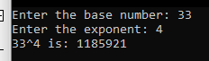

**Task 9:**

#include <stdio.h>

int calculateArraySum(int *arr, int size) {

    int sum = 0;

    int *ptrSum = &sum;

    for (int i = 0; i < size; ++i) {

        *ptrSum += arr[i];

    }

    return *ptrSum;

}

int main() {

    int size;

    printf("Enter the size of the array: ");

    scanf("%d", &size);

    int arr[size];

    printf("Enter %d elements:\n", size);

    for (int i = 0; i < size; ++i) {

        scanf("%d", &arr[i]);

    }

    int sum = calculateArraySum(arr, size);

    printf("Sum of elements in the array is: %d\n", sum);

    return 0;

}

**Output:**

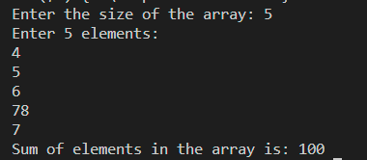

**Task 10:**

#include <stdio.h>

void subtractNumbers(int *result, int num1, int num2) {

    *result = num1 - num2;

}

int main() {

    int num1, num2, result;

    printf("Enter the first number: ");

    scanf("%d", &num1);

    printf("Enter the second number: ");

    scanf("%d", &num2);

    subtractNumbers(&result, num1, num2);

    printf("Result of subtraction: %d\n", result);

    return 0;

}

**Output:**

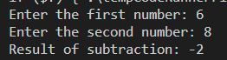

**Task 11:**

#include <stdio.h>

void compareNumbers(int *num1, int *num2) {

    if (*num1 > *num2) {

        printf("%d is greater than %d\n", *num1, *num2);

    } else if (*num1 < *num2) {

        printf("%d is greater than %d\n", *num2, *num1);

    } else {

        printf("%d and %d are equal\n", *num1, *num2);

    }

}

int main() {

    int num1, num2;

    printf("Enter the first number: ");

    scanf("%d", &num1);

    printf("Enter the second number: ");

    scanf("%d", &num2);

    compareNumbers(&num1, &num2);

    return 0;

}

**Output:**

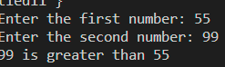

**Task 12:**

#include <stdio.h>

void calculateRectangleArea(float length, float width, float *area) {

    *area = length * width;

}

int main() {

    float length, width, area;

    printf("Enter the length of the rectangle: ");

    scanf("%f", &length);

    printf("Enter the width of the rectangle: ");

    scanf("%f", &width);

    calculateRectangleArea(length, width, &area);

    printf("Area of the rectangle is: %.2f\n", area);

    return 0;

}

**Output:**



**Task 13:**

#include <stdio.h>

void divideNumbers(double *result, double num1, double num2) {

    if (num2 != 0) {

        *result = num1 / num2;

    } else {

        *result = 0;

    }

}

int main() {

    double num1, num2, result;

    printf("Enter the numerator: ");

    scanf("%lf", &num1);

    printf("Enter the denominator: ");

    scanf("%lf", &num2);

    divideNumbers(&result, num1, num2);

    printf("Result of division: %.2lf\n", result);

    return 0;

}

**Output:**

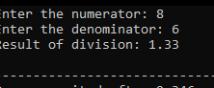

**Task 14:**

#include <stdio.h>

void multiplyNumbers(int *result, int num1, int num2) {

    *result = num1 * num2;

}

int main() {

    int num1, num2, result;

    printf("Enter the first number: ");

    scanf("%d", &num1);

    printf("Enter the second number: ");

    scanf("%d", &num2);

    multiplyNumbers(&result, num1, num2);

    printf("Result of multiplication: %d\n", result);

    return 0;

}

**Output:**

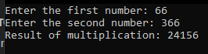

**Task 15:**

#include <stdio.h>

int main() {

    double radius;

    double circumference;

    printf("Enter the radius of the circle: ");

    scanf("%lf", &radius);

    double *ptr_radius = &radius;

    double *ptr_circumference = &circumference;

    *ptr_circumference = 2 * 3.14159 * (*ptr_radius);

    printf("Circumference of the circle: %.2lf\n", *ptr_circumference);

    return 0;

}

**Output:**

